Objective

Update the CDROMs structure and/or WebPages and burn an ISO image of it.

Scope

All CD-ROM ISOs that belong to the BCH Training Materials.

References

HELP: (Innovasy Help Studio System):
http://www.innovasys.com/

Definitions

CD-ROM ISO:
An ISO image is an archive file (a.k.a. disk image) of an optical disc using a conventional ISO (International Organization for Standardization) format that is supported by many software vendors. ISO image files typically have a file extension of .ISO.

Content

Update the CD-ROM content.

Copy the CD-ROM structure (containing files and folders) as-is and paste it to a local folder.

Update (Add, Delete, Modify files or folders) the CD-ROM content. The CD-ROM content is located in \fscommand\content\

If new files have been added then you will need to add some links to those files in the html files located in \fscommand\.

Create the CD-ROM ISO using a specialized software like Nero. Upload a zip file containing the ISO to UNEP-GEF ftp server.

Example

Context: UNEP-GEF release a new ready reference file (RR15En).

Copy the CD-ROM structure (containing files and folders) as-is and paste it to a local folder.

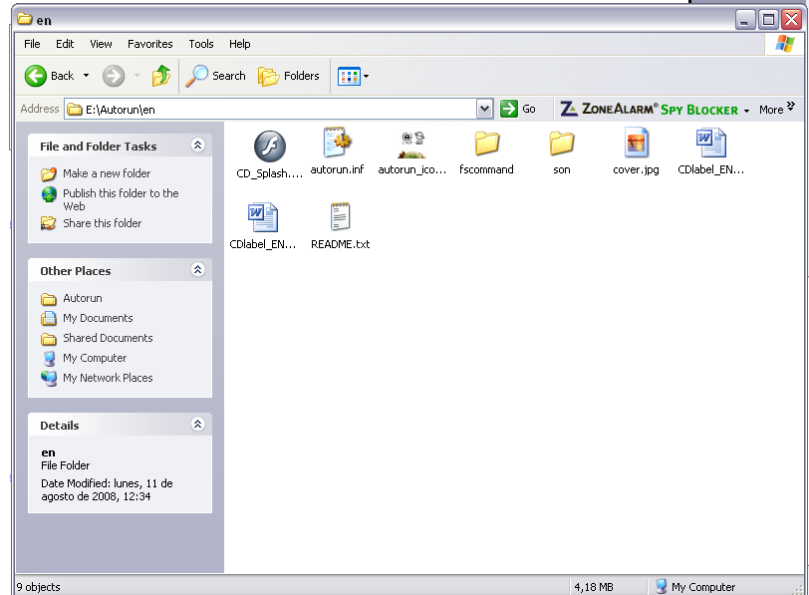

Add the new file to the “\fscommand\content\06) Ready Reference Guides” folder
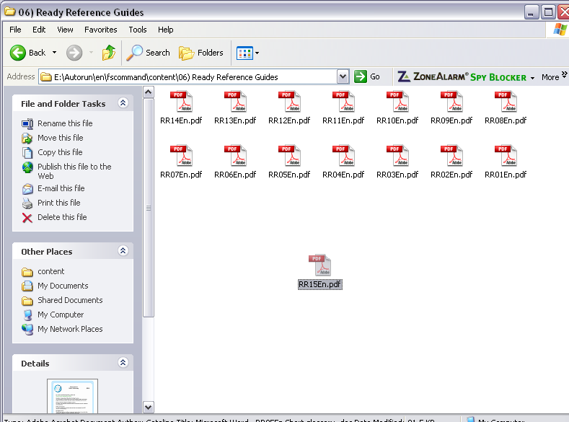

Add a link to the RR15En file in Ready_Reference_Guide.html located in “\fscommand\content\”.
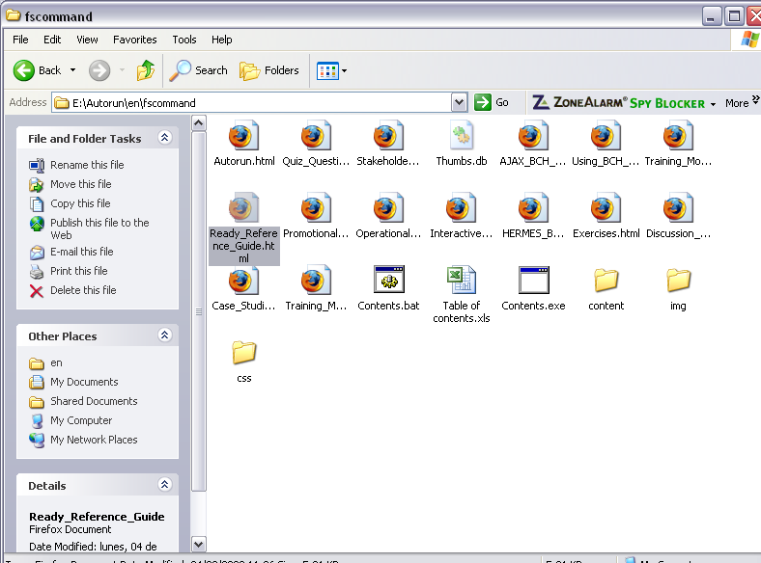

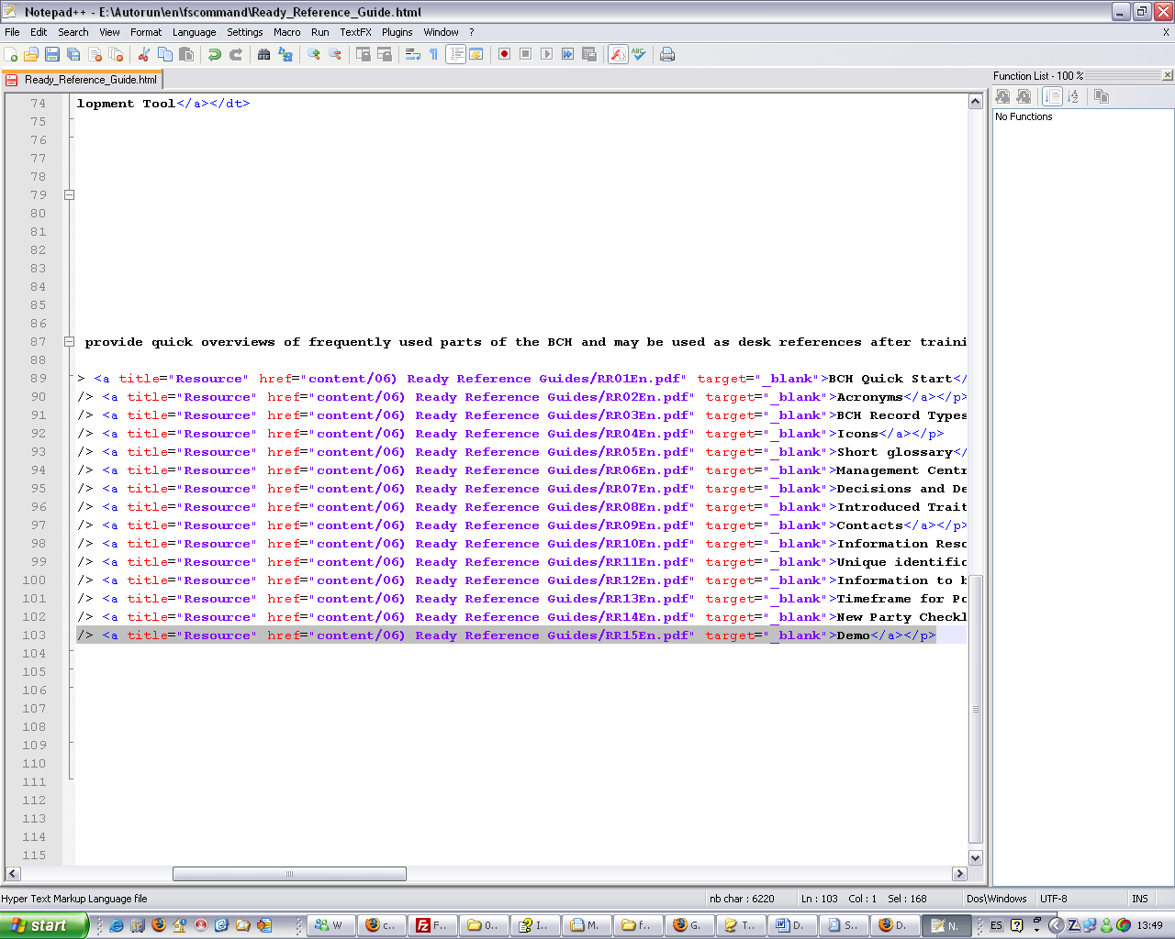

Create the CD-ROM ISO using a specialized software like Nero..
